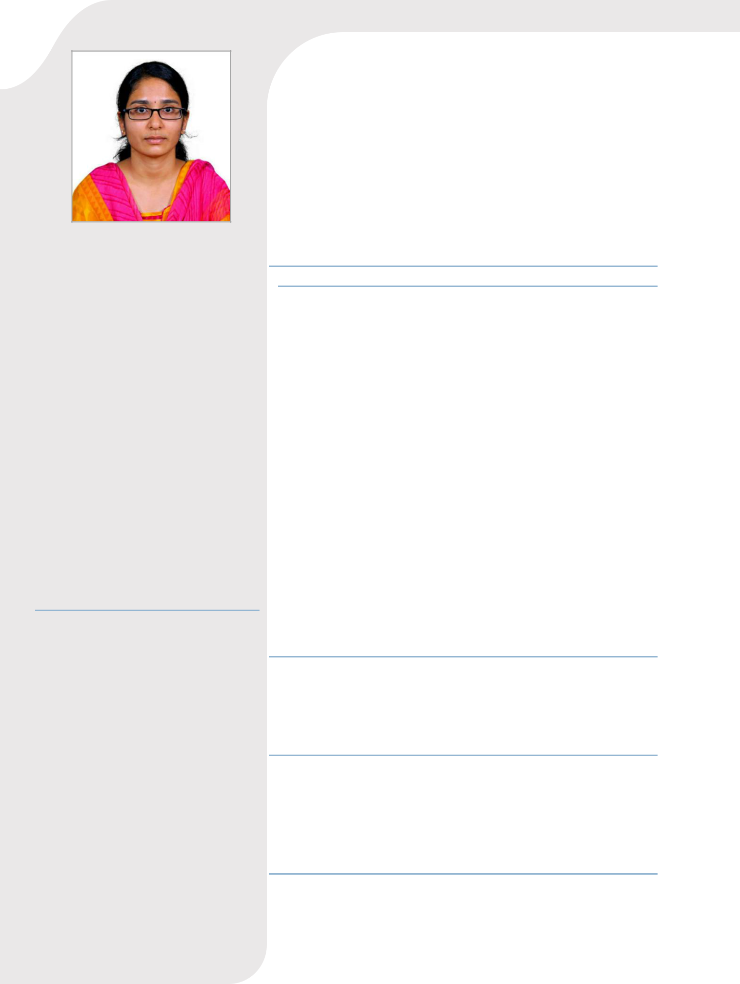

PROFILE

A positive and energetic professional seeking to be associated with a progressive organization that gives me the scope to share my knowledge and skills in accordance with the latest trends and to be a part of team that dynamically works towards the growth of organization.

CONTACT

PHONE:
+91- 9445284905

ADDRESS:

203, 200ft radial road, Alliance galleria, Jamin pallavaram, Chennai - 600043

EMAIL
yogashreegunasekaran@gmail.com

TECHNICAL SKILLS

- AutoCAD
- STAAD.Pro
- Manual Testing

YOGASHREE GUNASEKARAN

INTERSHIP EXPERIENCE

THANGAM ASSOCIATES, RASIPURAM Intern
January 2019 to April 2019

- Analyzed the load combination of structures and implemented designs based on the analysis Responsible for creating accurate 2D drawings reflecting the structure’s measurements using AutoCAD

- Responsible for evaluating the present scalable value of a property

- Learnt the construction techniques for various sites - Hospitals, Residential building (G+2), Temples and Poultry farms

- Performed the topography map analysis for re- positioning the existing railway tracks

EDUCATION

M. KUMARASAMY COLLEGE OF ENGINEERING

Karur

Bachelor of Engineering – Civil (2015-2019)
CGPA: 8.792

VIDYA NIKETAN MATRIC. HIGHER SECONDARY SCHOOL

Rasipuram

XII Standard (2013-2015)

Percentage: 90%

GOVERNMENT HIGHER SECONDARY SCHOOL

R.Pudupalayam

- Standard (2011-2013) Percentage: 96.6%

  PROJECTS |  |  |  | Project title: Plastic Roads.
 |  |  |  | The main objective of the project is to determine the
compressive strength and wear resistance of the road which is composited by plastic wastes.

DESIGN PROJECT Project on the title of Planning, Analyzing and Designing 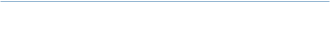 of IT Park Building at M.Kumarasamy College Of  Engineering

ACHIEVEMENTS Secured third place in fourth end semester examinations during the academic year 2016 - 2017.

CO-CURRICULLAR ACTIVITIES:

1.Undergone In-Plant Training at Sri Kumaran Builders in Rasipuram.

2.Attended a workshop on -

- Green technologies for environmental management at M.Kumarasamy college of engineering in Karur

- Building drawing and planning at M. Kumarasamy college of engineering in Karur.

- Standard penetration test at Dhirajlal Gandhi college of technology in Salem.

- Durability of pavement and its influence on urban road at Sri Ramakrishna engineering college in Coimbatore.

3.Completed as a trainee in the program of advanced total station course conducted by Ladder Survey institute of technology.

4.Admitted as a student member in Indian Concrete Institute for the period August 2016 to July 2019.

